**CITY INFO**

**PROBLEM STATEMENT-**

Tourism industry is a booming industry that enriches knowledge, brings social

Development and economic growth also. mService industries are of recent development in

India compared to developed nations. Nowadays, tourism and medical tourism are fast

growing areas. But, there are lots of problems faced by tourists during their tour due to

poor facilities, uncertainties, cleanliness, safety, etc. Dailies bring out reports on such

issues. Previously, people used to tour mainly on pilgrimage. But now, the culture has

changed. In our country also, many people plan for their tour as a regular affair may be

once in a year. In this growing field, it is highly important to study the major issues faced

by tourists and to take necessary steps to reduce such problems.

**In order to solve this problem we have decided to make a software which will have information about the places of that city like places for tourists,places of food zone,hospitality,markets ,malls ,hospitals etc.**

**The name of our software is the city info**

**Solution Domain-**

The problems like lack of information about the places of a city is solved in this software . Now it is easy for people to get information regarding any place in the city.

**Comparison b/w various s/w modeling techniques**

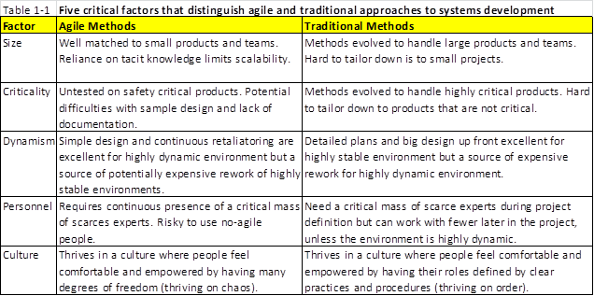

**Software method used in the software-**

* Agile method

AGILE methodology is a practice that promotes **continuous iteration** of development and testing throughout the software development lifecycle of the project. Both development and testing activities are concurrent unlike the Waterfall model

[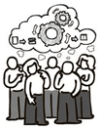](https://www.guru99.com/images/11-2014/agile_Processesv1_1.png)

The agile software development emphasizes on four core values.

1. Individual and team interactions over processes and tools
2. Working software over comprehensive documentation
3. Customer collaboration over contract negotiation
4. Responding to change over following a plan

**Agile Manifesto-**

1

Our highest priority is to satisfy the customer through early and continuous delivery of valuable software.

2

Welcome changing requirements, even late in development. Agile processes harness change for the customer’s competitive advantage.

3

Deliver working software frequently, from a couple of weeks to a couple of months, with a preference to the shorter timescale.

4

Business people and developers must work together daily throughout the project.

5

Build projects around motivated individuals. Give them the environment and support they need, and trust them to get the job done.

6

The most efficient and effective method of conveying information to and within a development team is face-to-face conversation.

7

Working software is the primary measure of progress.

8

Agile processes promote sustainable development. The sponsors, developers, and users should be able to maintain a constant pace indefinitely.

9

Continuous attention to technical excellence and good design enhances agility.

10

Simplicity–the art of maximizing the amount of work not done–is essential.

11

The best architectures, requirements, and designs emerge from self-organizing teams.

12

At regular intervals, the team reflects on how to become more effective, then tunes and adjusts its behavior accordingly.